**Laporan Modul 2**

Ivanovitcz Abdurrakhman Ar Raniri  
L200170153

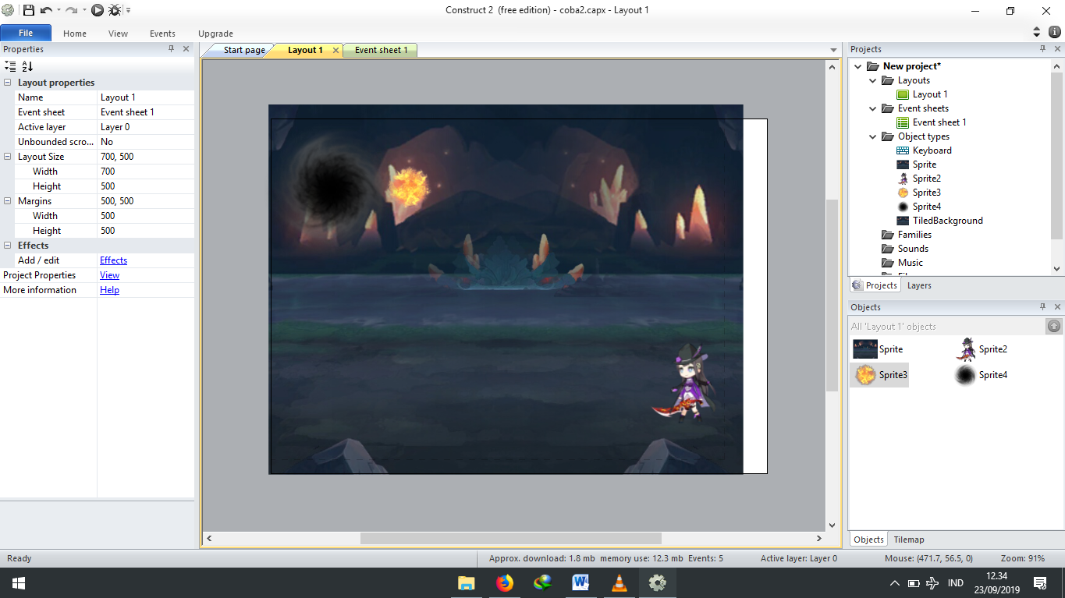

Objek 1

* 8Direction
* Wrap

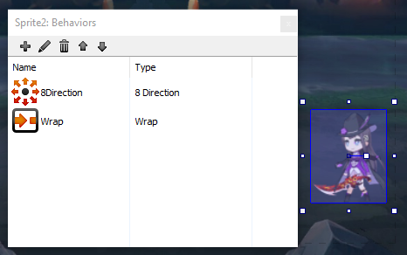

Objek 2

* Rotate

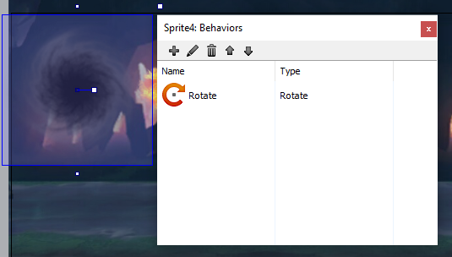

Objek 3

* Wrap
* Bullet

